Home:

NSBE News

Announcement

Opportunities

Member of the Month

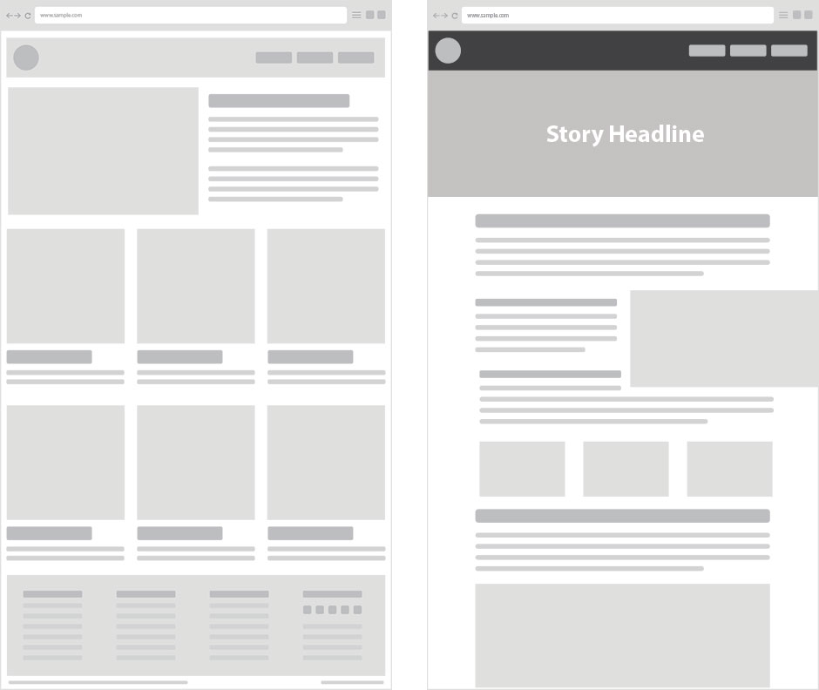

Is there a way to make the layout of the website like the graphic to the right ? And have subsections like the once above on the pages in that order

Events:

* Calendar
* General Body Meetings
* Events like Reach/ other outreach
* Fundrasing Events

Gallery:

* GBM Industry meetings gallery
* Events gallery

AASC Center CalPoly:

Link AASC website on CPP.edu

Join NSBE:

Good as is, for now.

Maybe add link to pay chapter membership online (I have to find out from ASI if we can do this) and link to pay national membership as well.

About us:

The National Society of Black Engineers (NSBE) began as a response to address the declining retention rates of African American students pursing degrees in engineering disciplines. As the efforts to coalesce and support students with additional resources intensified, NSBE broadened its umbrella of resources to support all student, minority and non-minority, to face up to the challenges that pursuing at education in engineering can bring.

Our mission is to create a world where engineering is an ordinary word in homes and communities of color, and all minority students can see themselves as engineers. By ensuring this mission comes to fruition, minority groups will surpass equivalency in entering and obtaining engineering degrees, as well as succeeding in their respective professions.

At Cal Poly Pomona, NSBE aims to work with students to make the college experience an enriching one. We focus on student retention, community involvements, industry relations and intra-organization community building to ensure a well-rounded outreach effort and to create a sense of family.

In our efforts in increase student retention, we have established NSBE Connect and NSBE CPP, which are platforms on GroupME. NSBE CPP is a messaging platform for NSBE members at large and can be used for keeping in touch with the community. NSBE Connect is a shared messaging space for NSBE members of the same major where advice of classes to take, study habits and personal study sessions are facilitated. This upcoming year we are introducing mentorships and study sessions, where all students can come study with us and help each other learn.

To have a positive impact in our community, we hold our NSBE Reach event, which bring elementary school students to explore the world of engineering at Cal Poly Pomona for a day. The goal is to follow up with these students to ensure the budding scientist seed we planted grows!

We provide opportunities for students to get acquainted with industry by inviting members of reputable engineering organizations and firms to come speak to and recruit members at our general body meetings. NSBE, as an organization, hosts the NSBE Annual National Convention and the quarterly Regional Conventions which invites hundreds of companiess, including Chevron, Lockheed Martin, Boeing and many more to recruit students for internships as well as provide career building workshops.

We offer many several incentives to our members such as Make the Grade, which members earn prizes for improving their quarterly GPAs and volunteer opportunities to keep you plenty busy all year round!

(You can shorten or edit this as needed. Lemme know if you want me to do this as well)

Create New Pages(I don’t know how possible this is):

Opportunities

* Scholarships
  + Link CPP scholarship and other ones we find along the way
* Research websites
  + Link NSF websites and other such websites
* Internship websites
  + Link CPP Career Center website and other websites good for searching for engineering
* Tips/Helpful Information